Store Inventory Optimization

DATA

import pandas as pd

from datetime import datetime, timedelta

import random

# Generate random data

data = []

start_date = datetime.now() - timedelta(days=365)

for i in range(1000): # Adjust this number to control the number of rows in the dataset

product_id = random.randint(1, 100)

product_name = f"Product_{product_id}"

category = random.choice(["electronics", "clothing", "toys", "books", "sports"])

price = round(random.uniform(10, 1000), 2)

units_sold = random.randint(1, 20)

date = (start_date + timedelta(days=i % 365)).strftime("%Y-%m-%d")

data.append([product_id, product_name, category, price, units_sold, date])

# Create a pandas DataFrame

columns = ["product_id", "product_name", "category", "price", "units_sold", "date"]

sales_data = pd.DataFrame(data, columns=columns)

# Display the first few rows of the dataset

print(sales_data.head())

# Save the dataset as a CSV file

sales_data.to_csv("sales_data.csv", index=False)

Output:  
 product_id product_name category price units_sold date

0 60 Product_60 books 54.89 14 2022-04-16

1 65 Product_65 toys 317.94 20 2022-04-17

2 55 Product_55 books 448.82 10 2022-04-18

3 45 Product_45 sports 396.37 11 2022-04-19

4 88 Product_88 clothing 421.31 2 2022-04-20

Remove any missing or duplicate data Analyze the dataset to understand the trends and patterns in the data. Create visualizations using bar charts, pie charts

import pandas as pd

import matplotlib.pyplot as plt

import seaborn as sns

# Read the dataset from the CSV file

sales_data = pd.read_csv("sales_data.csv")

# Remove missing values

sales_data.dropna(inplace=True)

# Remove duplicate rows

sales_data.drop_duplicates(inplace=True)

# Display the first few rows of the cleaned dataset

print(sales_data.head())

# Analyze the data: Total units sold by category

category_units = sales_data.groupby('category')['units_sold'].sum().reset_index()

# Bar chart: Units sold by category

plt.figure(figsize=(10, 5))

sns.barplot(x='category', y='units_sold', data=category_units)

plt.title('Units Sold by Category')

plt.show()

# Pie chart: Units sold by category

plt.figure(figsize=(10, 5))

plt.pie(category_units['units_sold'], labels=category_units['category'], autopct='%1.1f%%')

plt.title('Units Sold by Category')

plt.show()

# Analyze the data: Total sales by month

sales_data['date'] = pd.to_datetime(sales_data['date'])

sales_data['month'] = sales_data['date'].dt.strftime('%Y-%m')

monthly_sales = sales_data.groupby('month')['units_sold'].sum().reset_index()

# Bar chart: Units sold by month

plt.figure(figsize=(15, 5))

sns.barplot(x='month', y='units_sold', data=monthly_sales)

plt.title('Units Sold by Month')

plt.xticks(rotation=45)

plt.show()

# Analyze the data: Average price by category

category_prices = sales_data.groupby('category')['price'].mean().reset_index()

# Bar chart: Average price by category

plt.figure(figsize=(10, 5))

sns.barplot(x='category', y='price', data=category_prices)

plt.title('Average Price by Category')

plt.show()

Output:

product_id product_name category price units_sold date

0 60 Product_60 books 54.89 14 2022-04-16

1 65 Product_65 toys 317.94 20 2022-04-17

2 55 Product_55 books 448.82 10 2022-04-18

3 45 Product_45 sports 396.37 11 2022-04-19

4 88 Product_88 clothing 421.31 2 2022-04-20

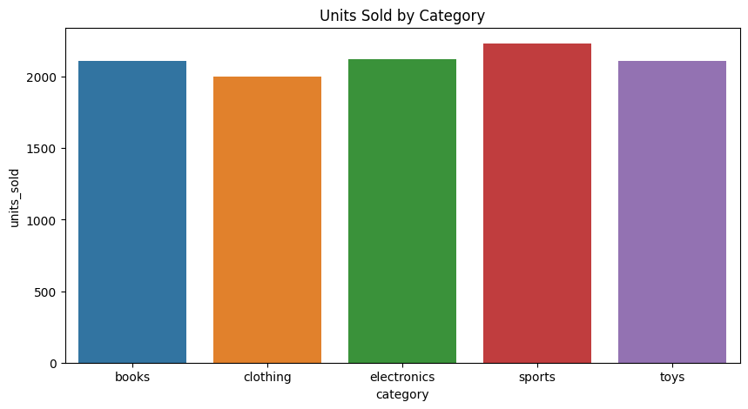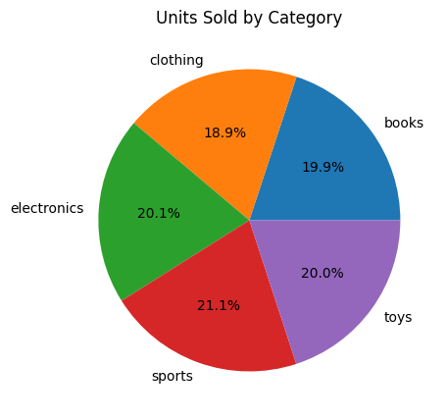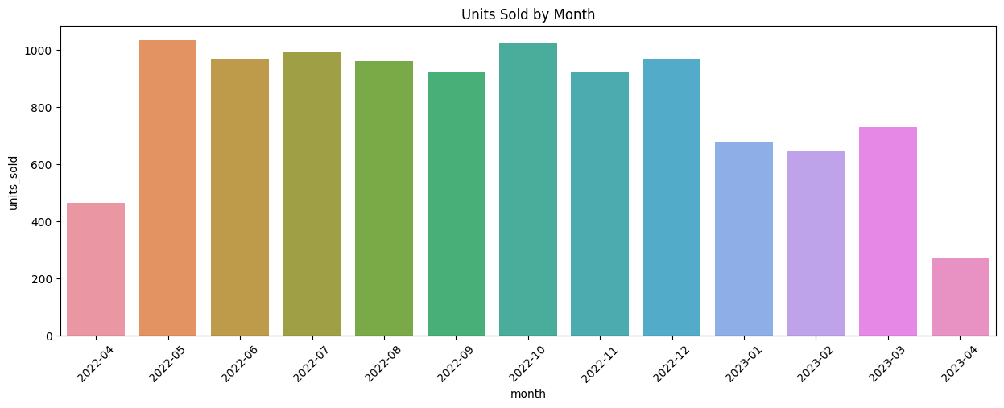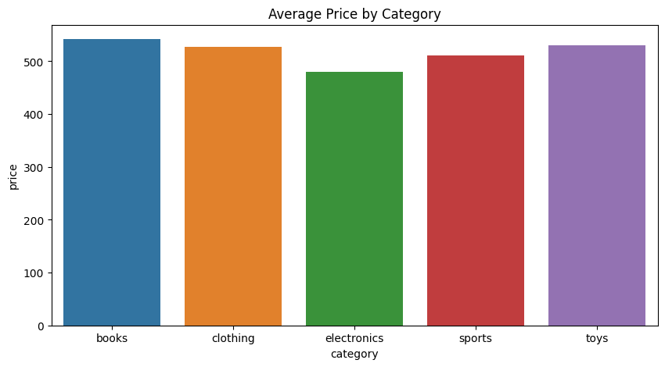

Average daily sales Standard deviation of daily sales Sales velocity bargraph

import numpy as np

import random

# Calculate average daily sales and standard deviation for each product

product_daily_sales = sales_data.groupby(['product_id', 'product_name', 'date'])['units_sold'].sum().reset_index()

product_metrics = product_daily_sales.groupby(['product_id', 'product_name']).agg(

avg_daily_sales=('units_sold', np.mean),

std_daily_sales=('units_sold', np.std),

).reset_index()

# Assuming a hypothetical total stock for each product

total_stock = {product_id: random.randint(50, 200) for product_id in product_metrics['product_id'].unique()}

# Calculate sales velocity for each product

product_metrics['total_stock'] = product_metrics['product_id'].apply(lambda x: total_stock[x])

product_metrics['sales_velocity'] = product_metrics['avg_daily_sales'] / product_metrics['total_stock']

# Display the first few rows of the calculated metrics

print(product_metrics.head())

# Bar chart: Average daily sales by product

plt.figure(figsize=(20, 8))

sns.barplot(x='product_id', y='avg_daily_sales', data=product_metrics)

plt.title('Average Daily Sales by Product')

plt.xticks(rotation=90)

plt.show()

# Bar chart: Standard deviation of daily sales by product

plt.figure(figsize=(20, 8))

sns.barplot(x='product_id', y='std_daily_sales', data=product_metrics)

plt.title('Standard Deviation of Daily Sales by Product')

plt.xticks(rotation=90)

plt.show()

# Bar chart: Sales velocity by product

plt.figure(figsize=(20, 8))

sns.barplot(x='product_id', y='sales_velocity', data=product_metrics)

plt.title('Sales Velocity by Product')

plt.xticks(rotation=90)

plt.show()

product_id product_name avg_daily_sales std_daily_sales total_stock \

0 1 Product_1 9.666667 7.126561 50

1 2 Product_2 11.545455 5.989385 153

2 3 Product_3 11.214286 5.146748 162

3 4 Product_4 6.142857 6.938505 105

4 5 Product_5 12.000000 5.009083 184

sales_velocity

0 0.193333

1 0.075460

2 0.069224

3 0.058503

4 0.065217

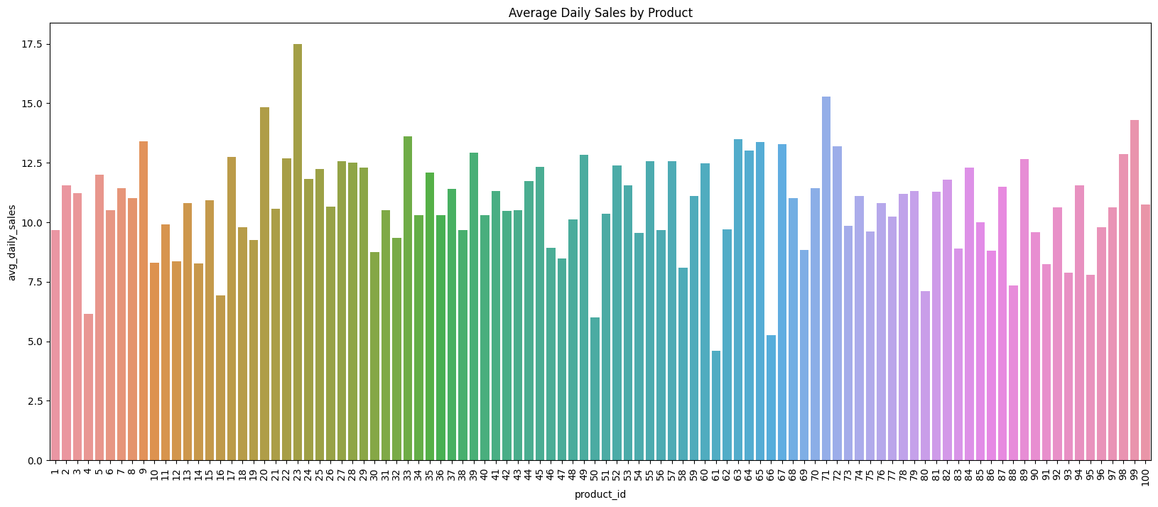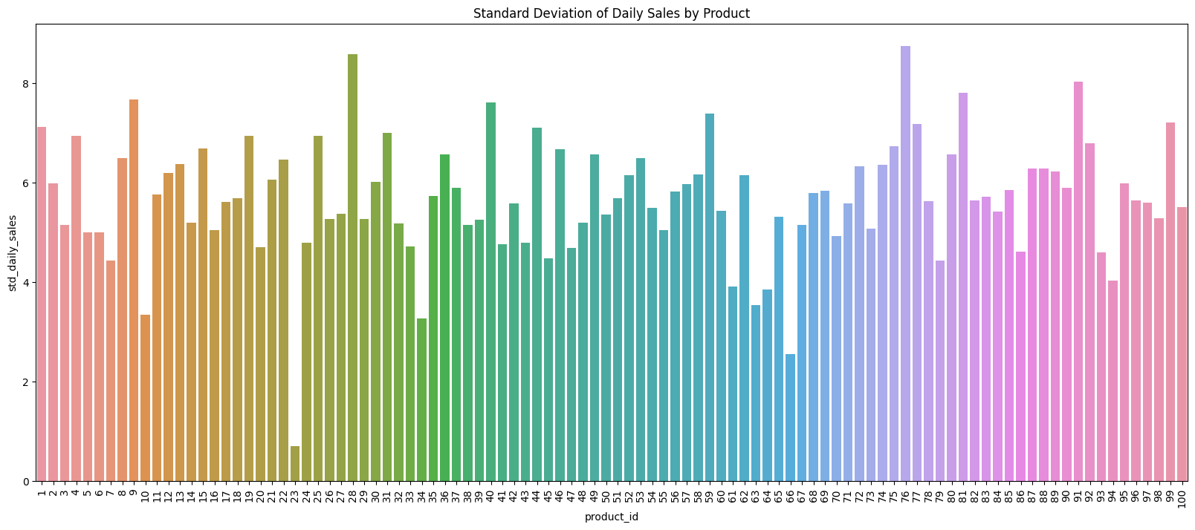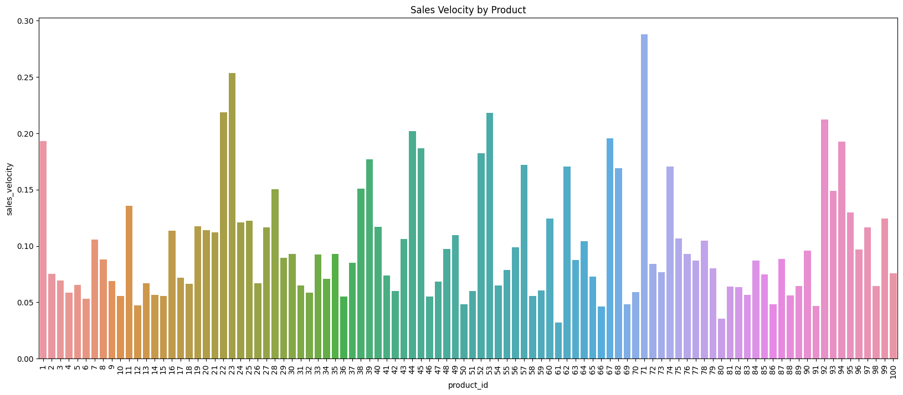

seasonal trend

# Analyze the data: Total sales by month and category

monthly_category_sales = sales_data.groupby(['month', 'category'])['units_sold'].sum().reset_index()

# Create a pivot table for better visualization

pivot_monthly_category_sales = monthly_category_sales.pivot_table(index='month', columns='category', values='units_sold').fillna(0)

# Bar chart: Monthly sales by category

pivot_monthly_category_sales.plot.bar(stacked=True, figsize=(15, 8))

plt.title('Monthly Sales by Category')

plt.xticks(rotation=45)

plt.ylabel('Units Sold')

plt.show()

# Line chart: Monthly sales by category

pivot_monthly_category_sales.plot.line(marker='o', figsize=(15, 8))

plt.title('Monthly Sales by Category')

plt.xticks(rotation=45)

plt.ylabel('Units Sold')

plt.show()

